**Practical - 1**

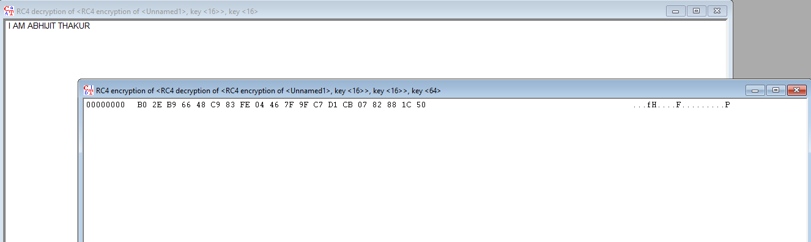

**Step -1: Opening CrypTool**



**Step - 2 : Click on Encrypt/Decrypt and select Symmetric(morden)**

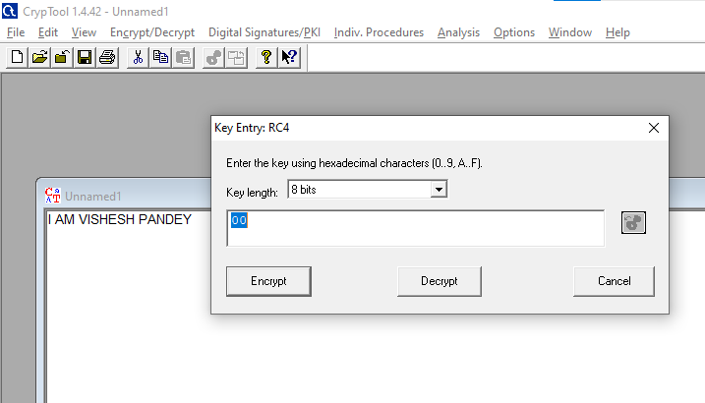

**Step-3 : Select RC-4**

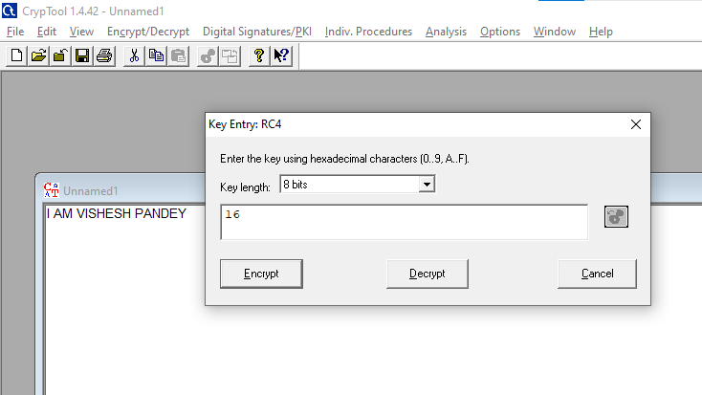

**Step-4 : Select 8 bits and enter 16**

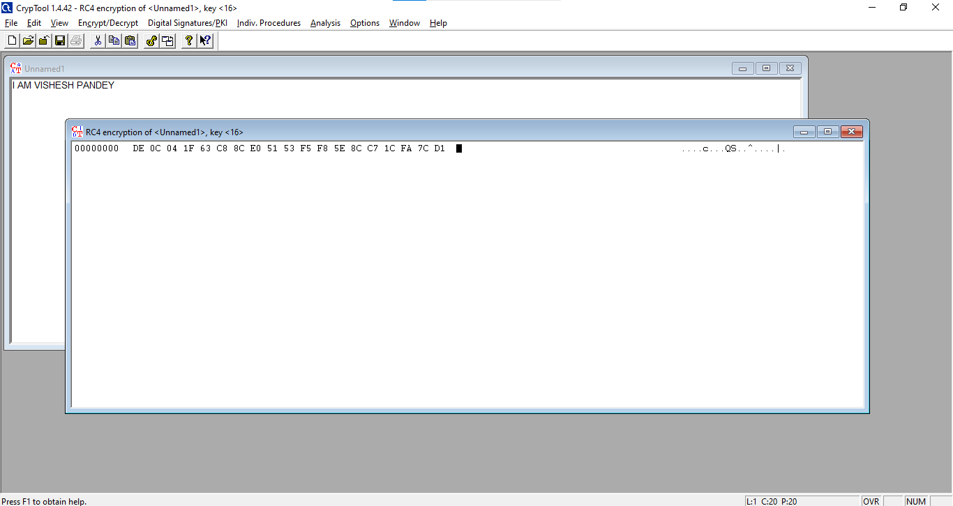

**Step-5 : You will get encrypted text.**

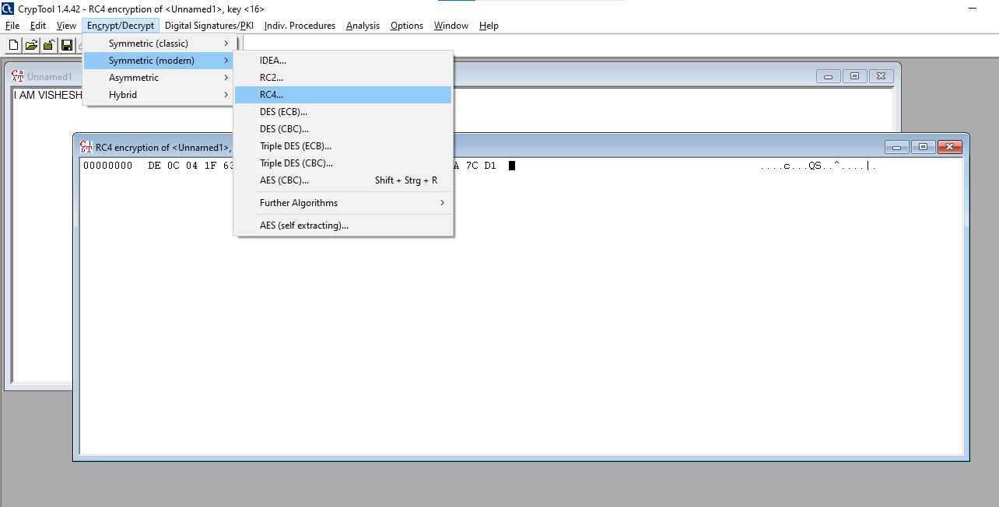

**Step-6: Now decrypt in the same way**

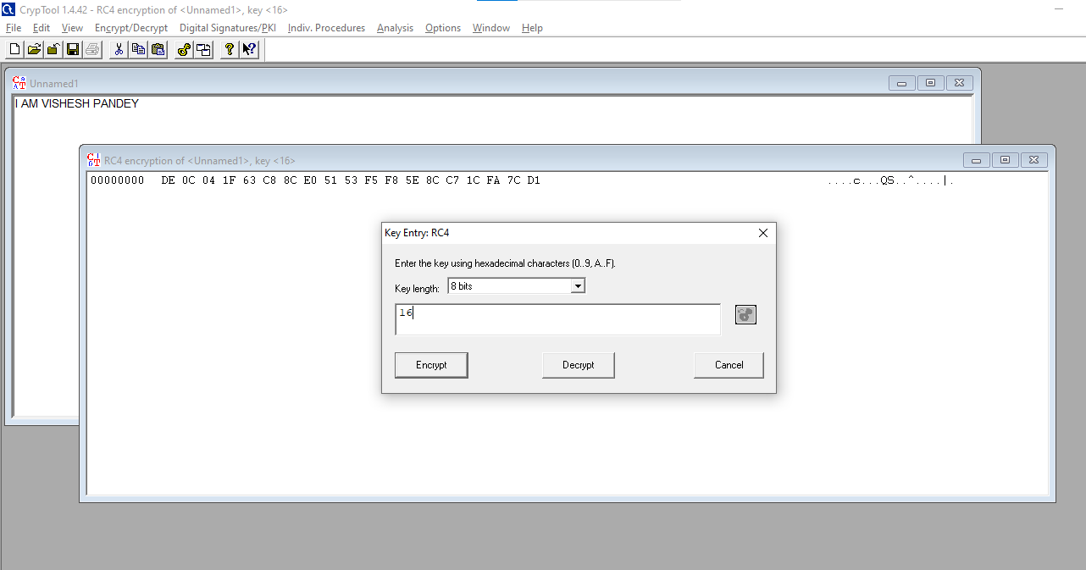

**Step - 7 : Enter value as 16**

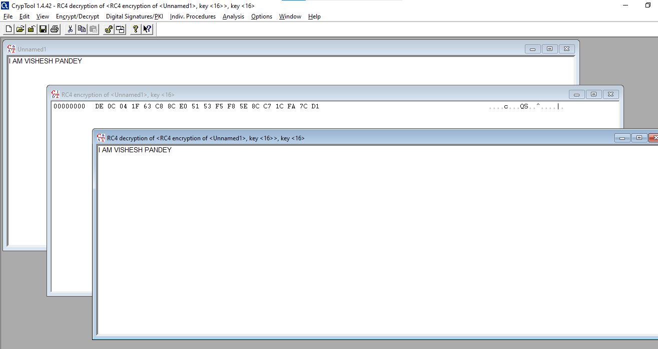

**Step - 8 : You will get decrypted text.**